Technology Context: Product Design
Year: 10
Unit Title: Product Design | Duration: 4 weeks (12 x 72 minute lessons)
Unit Overview:
In this unit students explore a broad range of traditional, contemporary and emerging materials that involve an extensive use of technologies. Students learn to make ethical and sustainable decisions about designed solutions and processes by learning about and working with a variety of materials and more advanced production processes.

VCAA Design and Technologies Levels 9-10
Curriculum Context – Materials and Technologies Specialisations:
Investigate and make judgements on how the characteristics and properties of materials, systems, components, tools and equipment can be combined to create designed solutions (VCDSTC059)

This unit plan is based on the major aspects of design thinking, design processes and production processes. The content descriptors in this strand reflect a design process which is addressed through a design brief.

Creating Designed Solutions:
- Investigating – Critique needs or opportunities to develop design briefs and investigate and select an increasingly sophisticated range of materials, systems, components, tools and equipment to develop design ideas (VCDSCD060)
- Generating – Apply design thinking, creativity, innovation and enterprise skills to develop, modify and communicate design ideas of increasing sophistication (VCDSCD061)
- Producing – Work flexibly to safely test, select, justify and use appropriate technologies and processes to make designed solutions (VCDSCD062)
- Evaluating – Evaluate design ideas, processes and solutions against comprehensive criteria for success recognising the need for sustainability (VCDSCD063)
- Planning and managing – Develop project plans to plan and manage projects individually and collaboratively taking into consideration time, cost, risk and production processes (VCDSCD064)

Technology and Society
- Critically analyse factors, including social, ethical and sustainability considerations, that impact on designed solutions for global preferred futures and the complex design and production processes involved (VCDSTS054)
- Explain how designed solutions evolve with consideration of preferred futures and the impact of emerging technologies on design decisions (VCDSTS055)

https://victoriancurriculum.vcaa.vic.edu.au/technologies/design-and-technologies/curriculum/f-10#level=7-8

Teaching Strategies:
This unit incorporates learning and teaching experiences that are student centred, differentiated and informed by timely and authentic feedback. Teaching strategies are consistent with examples outlined in the Caroline Chisholm Catholic College Learning and Teaching Policy. (The Policy is available on the College Intranet).

Key Knowledge & Skills:
- Working through the design process to create designed solutions relevant to a design brief
- Establish criteria for success, including sustainability considerations and use these to evaluate their ideas and designed solutions and processes
- Generating and connecting design ideas and processes of increasing complexity and justify their decisions
- Communicate and document projects, including marketing for a range of audiences
- Independently and collaboratively apply sequenced production and management plans when producing designed solutions, making adjustments to plans when necessary
- Select and use appropriate technologies skilfully and safely to produce quality designed solutions suitable for the intended purpose
- Evaluate working through the design process and make recommendations for future improvements

Assessment Details:
Learning Task 1: Biomimicry; plastic pouch inspired by nature

Learning and Teaching Timeline: Biomimicry; plastic pouch inspired by nature
Design situation
- Pouches are a great way to store personal items safely in a larger bag, items like a mask, hand sanitizer, period products and headphones need safe storage.
- The design and manufacture of small items should not be taxing on the environment, designers should aim to reuse and connect with nature.
- Nature is perfectly designed, investigate how nature can inspire the aesthetics of the pouch design.
Design Brief
- Design and make a small pouch that fits personal items. It should reuse materials and extend your skills.
Design constraints
- Fits your personal items, made from fused plastic and plastic and can be made in a 4 week period *student to add three more
- Demonstrate skills in; embroidery, machine sewing, and apply visual concepts of biomimicry

Week(s) | Lesson 1  Include a list of teaching and learning activities that could occur  Include details of assessment and practical sessions | Lesson 2  Include a list of teaching and learning activities that could occur  Include details of assessment and practical sessions | Lesson 3  Include a list of teaching and learning activities that could occur  Include details of assessment and practical sessions | What variations are possible for student with different needs?
1  Plastic Zip Pouch – DESIGN BRIEF & VISUALISTAION | - Getting to know you activities such as: roll call games, name that tool!  - Establish some guidelines and class expectations, materials required for class - what is product design? https://museumsvictoria.com.au/melbournemuseum/learning/top-designs-2020/  - Show them picture examples of the pouch project/inspiration samples and introduce brief  - Start book, leave first page- create a unit glossary as second page, add/Define; biomimicry, sustainability, LCA, Life Cycle Thinking, carbon footprints, cradle to cradle - https://victoriancurriculum.vcaa.vic.edu.au/LearningArea/LoadFile?learningArea=technologies&subject=design-and-technologies&name=Design%20and%20Technologies%20Glossary.docx&storage=Glossary  - Use small calico pieces of fabric, make some samplers to glue into books, talk and chat through goals for the course while students sew  - Simple embroidery stitches - https://www.dmc.com/uk/p-embroidery-stitch-guide.html  - Practicing hand embroidery - https://www.pinterest.com.au/1moniqued/textiles-techniques/ | - Walk the school grounds and collect leaves/natural matter, bring these back to class and do a drawing exercise on shape and form  - Glue and stick in leaves on title page, press some flowers - https://www.bhg.com/gardening/design/projects/make-pressed-flowers/  - Transferring inspiration drawings into products  - Orthogonal sketch features  - Drawing a plastic zip pouch in orthogonal style  - Drawing leaves and nature, adding simple visual features like texture and colour tone:  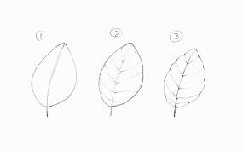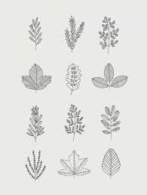 | - Look at pressed flowers and leaves, do a drawing exercise to trace/transpose and model shapes seen in the flowers and leaves  - Complete simple embroidery stitches - transfer simple line drawing into embroidery - TRY and get students to move from cliché into inspired  - Spend lesson making samples, evaluating each other's work and drawing parallels between line shapes and nature - https://www.pinterest.com.au/1moniqued/biomimicry/  - While we sew, watch: https://online.clickview.com.au/exchange/videos/27613/to-innovate-is-to-imitate *start episode from 22min mark  - Biomimicry robots - https://education.abc.net.au/home#!/media/1974786/  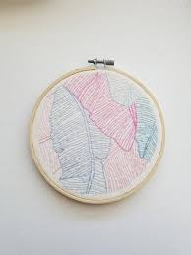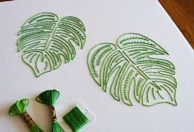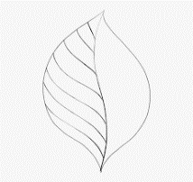 | - Grid paper  - Drawing templates  - Drafting shapes with chalk on fabric  - Providing exemplars to extend students
2  Plastic Zip Pouch - PRODUCTION | - Plastic bag ban - https://fuse.education.vic.gov.au/Resource/LandingPage?ObjectId=2e8f1774-09a4-4d2c-90fa-db3ae8f8021c&SearchScope=All  - More plastic in the ocean than plankton - https://www.exploratorium.edu/blogs/spectrum/more-plastic-plankton-ocean  - Plastic classification by symbol sight, glue symbol sheet into books  - Students watch demonstration of plastic fusing and create their own fused plastic - https://www.bhg.com.au/recycled-fused-plastic-bags  - Run through iron safety and instructions. Students practice fusing - https://davehakkens.nl/community/forums/topic/working-with-plastic-bags/  - Experimentation with hand sewing on fused plastic | 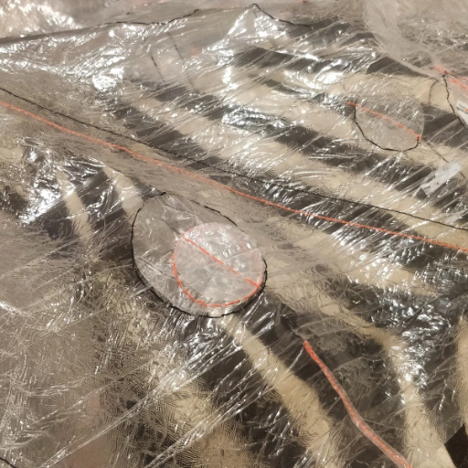  - Students continue to experiment with plastic, in groups move to the sewing machine  - Demonstrate sewing machine operation and set up  - Seam construction  - Sewing machine practice on calico fabric, simple seams, focus on neatness | - Create a fused plastic sample  - Create sample seams (open/closed)  - Sew fused plastic  - Experiment with shapes, layers and reference biomimicry in the visual appeal  - Have a finished design drawing of their pouch - colour  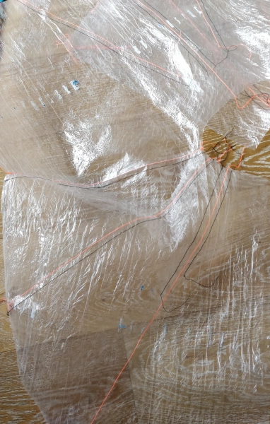 | - Partner pairs for prac  - Chalk on fabric for sewing guides
3 & 4  Plastic Zip Pouch - PRODUCTION | - Plastic bag task sheet - https://moniquedalli.files.wordpress.com/2020/03/plastic.pdf  - Zipper insertion, lapped method used, compare with invisible zip Lapped: https://www.youtube.com/watch?v=O3cgrHnvd8w invisible: https://www.youtube.com/watch?v=zo5FRoSmjHc  - Embroider their nature inspired designs on their pouch  - Assemble the pouch - https://mellysews.com/sew-zipper-pouch/ | - Facilitate and support students through self-paced practical work  - Constructing the pouch, neat seams, checking their work quality before moving to then next step |  | - Extension – lined pouch

Assessment Task & Rubrics

1. Task Title: Biomimicry; plastic pouch inspired by nature
2. Task Description/Design Brief:
- Design and make a small pouch that fits personal items. It should reuse materials and extend your skills.

3. Items to be submitted:
- Class workbook with leaf study drawings, samples and other classwork for feedback
- Drawn ideas and final working drawing of the product, written evaluation present that aligns solution to the brief
- Research the life cycle of a plastic bag
- Create a lifecycle CHART that depicts the life cycle of your pencil case
- Find some statistics that emotively promote your plastic pencil case and include in your submission

You are a DESIGNER working in PRODUCT DESIGN - therefore there is a level of presentation that is required to make this PROJECT LOOK GOOD!
4. Due Date:
5. Resources and links to help you:
https://mellysews.com/sew-zipper-pouch/
https://www.bhg.com.au/recycled-fused-plastic-bags
https://www.pinterest.com.au/1moniqued/biomimicry/
https://moniquedalli.files.wordpress.com/2020/03/plastic.pdf

Design Folio Ideas - Criteria | Achievement
Has presented design options and annotations in a way that is beyond the skills and level expected. | Extending
Demonstrates outstanding creativity and competence in expressing and evaluating a range of appropriate ideas clearly. | Proficient
Demonstrates competence in expressing viable ideas and evaluates those ideas clearly. | Consolidating
Demonstrates some competence in expressing appropriate ideas, with a sound evaluation. | Developing
Provides some evidence of simple ideas / solutions for the design brief, with elementary evaluation. | Beginning
Provides limited evidence of simple ideas / solutions for the design brief. | Needs Attention

Practical - Time Management - Criteria | Achievement
Completed set task at hand in the time allowed and also managed to support other students in the class/complete an extension task as well. | Extending
Demonstrates an extensive understanding of the management of processes and resources to successfully complete the end product by the due date. Completed set task on time and supported others in the class with help. | Proficient
Demonstrates a thorough understanding of the management of processes and resources to successfully complete the end product by the due date. | Consolidating
Demonstrates a sound understanding of the management of processes and resources to complete the end product by the due date. | Developing
Demonstrates a basic understanding of the management of processes and resources to complete the end product by the due date. | Beginning

Practical Project - Criteria | Achievement
Applies Skills and techniques in new contexts to create an outstanding quality finished product. The end product reflects the needs of the brief. | Extending
Demonstrates extensive skill development to produce an outstanding end product (must have additional design features and a higher level of difficulty), reflecting the needs of the Design Brief. | Proficient
Demonstrates thorough skill development to produce a high-quality end product reflecting the needs of the Design Brief. | Consolidating
Demonstrates sound skill development to produce an end product reflecting the needs of the Design Brief. | Developing
Demonstrates basic skill development to produce an end product reflecting the needs of the Design Brief. | Beginning
Demonstrates elementary skill development / or poor attitude to class work to produce an end product. | Needs Attention

Safety - Criteria | Achievement
Follows safe work practices independently, identifying risks while using equipment respectfully and responsibly in the development of a design project. | Proficient
Follows safe work practices, identifying risks while using equipment responsibly in the development of a design project. | Consolidating
Follows safe work practices using equipment responsibly in the development of a design project. | Developing
Follows safe work practices, using most equipment in the development of a design project. | Beginning
May follow safe work practices when prompted. | Needs Attention

